1.

Swift Extension is a useful feature that helps in adding more functionality to an existing Class, Structure, Enumeration or a Protocol type. This includes adding functionalities for types where you don’t have the original source code too (extensions for Int, Bool, String etc. types).

2.

We have not covered the delegates topic in our session.

3.

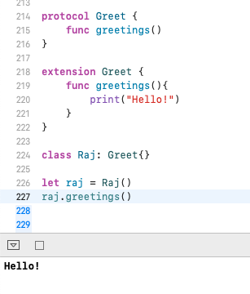

4.

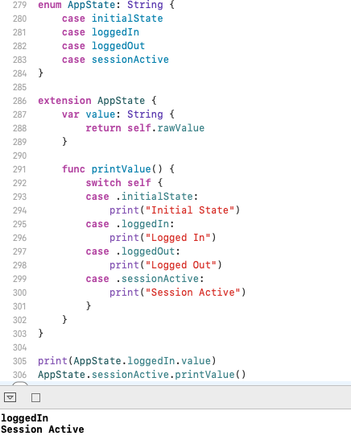

5.

Generic code enables you to write flexible, reusable functions and types that can work with any type, subject to requirements that you define. You can write code that avoids duplication and expresses its intent in a clear, abstracted manner.

6.

E.g.

Swift’s Array and Dictionary types are both generic collections. You can create an array that holds Int values, or an array that holds String values, or indeed an array for any other type that can be created in Swift. Similarly, you can create a dictionary to store values of any specified type, and there are no limitations on what that type can be.

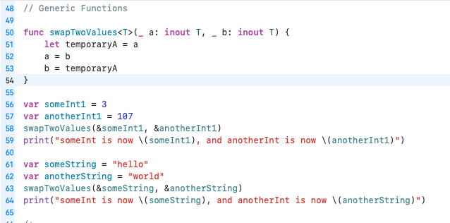

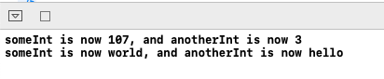

7.

**Map**

This higher order function loops over a collection and applies the same operation to each element in the collection.

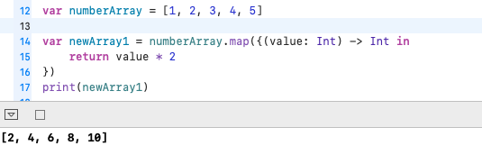

**CompactMap**

CompactMap is same as the Map function with optional handling capability. CompactMap is also used to filter out the nil value.

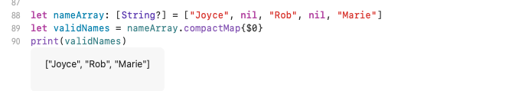

8.

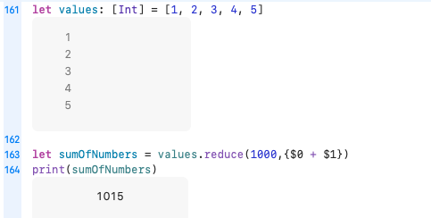

9.

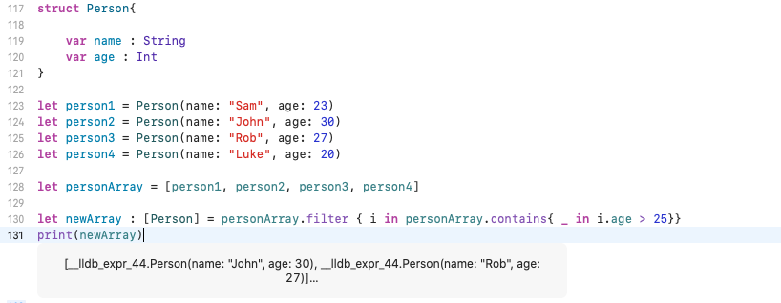

10.

